Title of ICMC 2026 Conference Paper
Author A¹, Author B¹, & Author C²
¹Affiliation 1, City, Country/Region (e.g., The University of Hong Kong, Hong Kong, China)
²Affiliation 2, City, Country/Region
xxx@xxx.com (Author A email address)
Abstract: Please write a single-paragraph abstract of no more than 250 words that covers: 1) your research problem and why it matters, 2) the specific limitation or gap in prior work, 3) your proposed methodology, 4) the main results and findings, and 5) the contribution and implications. Do not include citations, tables, figures, footnotes, or displayed equations. Note: The extended abstract is longer than the abstract in the conference paper and provides a more informative snapshot of the methodology and findings. Unless otherwise specified, keep it within 700 words and submit it by the deadline stated in the call (i.e., before 15 May 2026). The extended abstract is optional, but we strongly suggest that you submit it.

Author’s Instructions
We ask authors to replace all placeholder text with their own content while keeping the formatting rules unchanged. The full paper should not exceed 8 pages. We also ask authors to ensure the language is clear and technical, and to verify that all data, names, and references are accurate.

Main body
The main body could be organized with clear section headings and a logical flow. The following sections are provided for reference:
- Introduction: State the problem context and motivation, clearly identify the research gap, and summarize the paper’s objectives and contributions. Briefly outline the methodology and, where appropriate, describe the paper structure at the end of the section.
- Literature Review: Review and compare the most relevant prior work, highlighting key limitations and challenges.
- Methodology: Describe the proposed methodology in a reproducible manner. Define all symbols/variables on first use, specify assumptions, and provide sufficient implementation details (e.g., model architecture, parameter settings, hardware/software environment, and training/evaluation protocol) to enable replication. If datasets are used, describe data sources, preprocessing, and splits.
- Results: Present results with appropriate quantitative and/or qualitative evidence. Use figures and tables when they improve clarity; ensure they are numbered, captioned, and referenced in the text.
- Discussion: Report evaluation metrics and baselines, and discuss robustness (e.g., sensitivity analysis, ablations, uncertainty/error analysis) when relevant. Interpret findings objectively and relate them back to the research questions and prior work.
- Conclusions: Summarize key findings and contributions without repeating the full Results section. Discuss implications, main limitations, and concrete directions for future work.

Fonts
Please use Times New Roman throughout the paper. The title should be centered and set in 14-point bold. Please use no more than two heading levels; the recommended font sizes are as follows: Level-1 headings should be 12-point bold, Level-2 headings should be 11-point bold, and the main body text should be 11-point, single-spaced, fully justified.

Figures and Tables
Figures and tables should be placed close to where they are first cited in the text. They should be numbered consecutively (e.g., Figure 1, Figure 2; Table 1, Table 2). Please ensure that all figures and tables remain legible when printed at 100% scale. A figure template is shown in Figure 1.
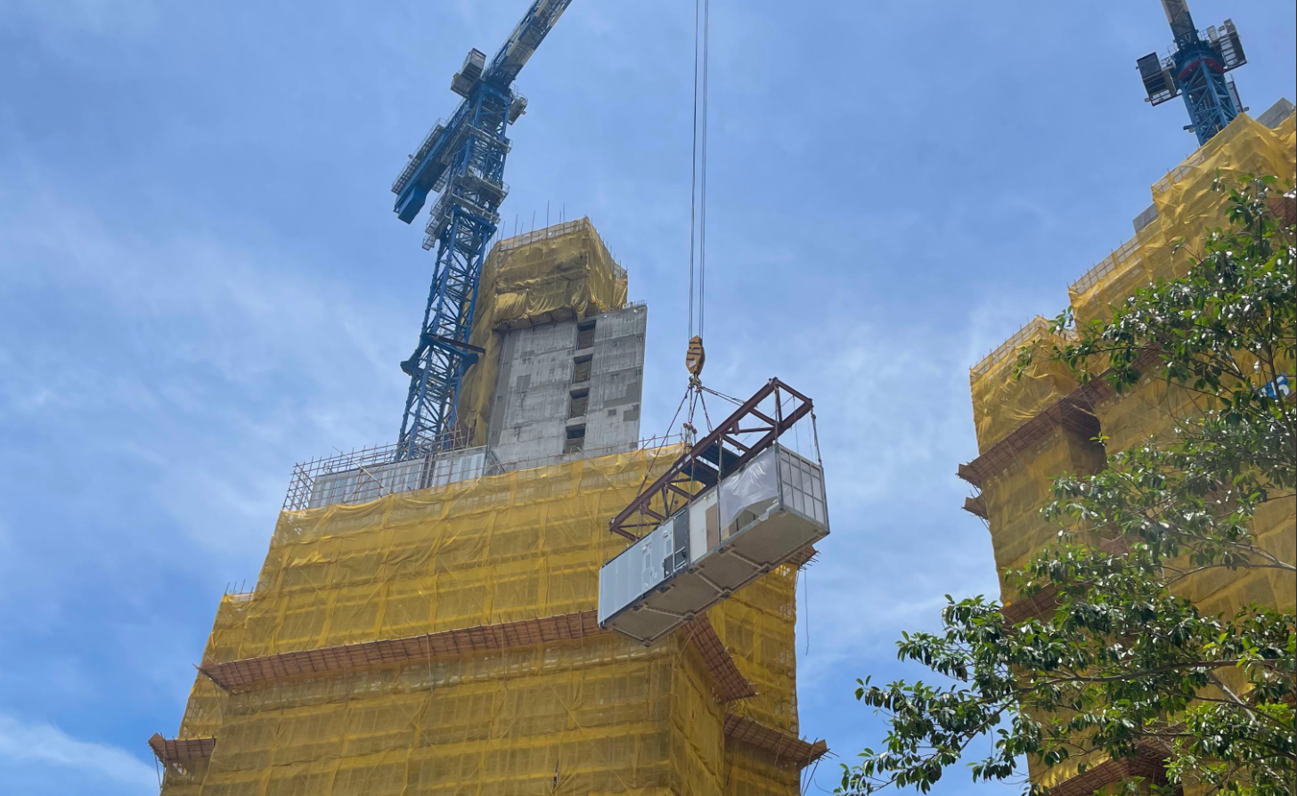
Figure 1: Sample of the figure
Tables should follow a clean “three-line” style (top rule, header rule, bottom rule) and avoid vertical borders. A table template is shown in Table 1.
Table 1: Sample of the table
 | Issue 1 | Issue 2 | Issue 3 | Issue 4
Item 1 | xxx | xxx | xxx | xxx
Item 2 | xxx | xxx | xxx | xxx
Item 3 | xxx | xxx | xxx | xxx

Equations
Important equations should be displayed on separate lines, centered, with equation numbers aligned to the right. All symbols should be defined at first use. Please use italics for scalar variables (e.g., $m$) and boldface for vectors and matrices (e.g., $F$, $a$).
$F=ma$ (1)

Citations and References
Please use APA author-date citations in the text and ensure that every in-text citation has a corresponding entry in the reference list (and vice versa). For example, use “Pan et al. (2020)” for three or more authors, and use “Pan and Zhang (2023)” when there are two authors. When citing multiple sources in one place, list them consistently (e.g., in alphabetical order) and keep the formatting uniform.
The References section should list entries alphabetically by the first author’s surname. Please use a hanging indent and apply consistent punctuation, capitalization, and italicization across all entries. Please include complete bibliographic information (e.g., authors, year, title, venue/publisher, volume/issue and page range).

References
Pan, W., & Zhang, Z. (2023). Benchmarking the Sustainability of Concrete and Steel Modular Construction for Buildings in Urban Development. Sustainable Cities and Society, 90, 104400.
Pan, W., Zhang, Z., Xie, M., & Ping, T. (2020). Modular Integrated Construction Performance Measurement Guidebook. ISBN: 9789628014286. Department of Civil Engineering, The University of Hong Kong.
Yu, C., Pan, W., & Liang, Y. (2024). Parametric analysis of the effect of window blind control on energy consumption of high-rise office buildings in high-density cities. In: The 5th Asia Conference of the International Building Performance Simulation Association (IBPSA 2024). Osaka, Japan.

